Assignment -4

Internet of Things (IoT)

|  |  |
| --- | --- |
| Assignment Date | 19 November 2022 |
| Student Name | Karthikeyan.S |
| Student Roll Number | 814419106003 |
| Maximum Marks | 2 Marks |

1.Write Code and connections in wokwi for ultrasonic sensor. whatever Solution:

//Pins const int TRIG_PIN = 7 ; const int ECHO_PIN = 8;

//Anything over 400 cm (23200 us pulse) is "out of range" const unsigned

int MAX_DIST = 23200;

void setup() {

// The Trigger pin will tell the sensor to range find Pin

Mode(TRIG_PIN, OUTPUT);

digital Write(TRIG_PIN, LOW);

//Set Echo pin as input to measure the duration of

//pulses coming back from the distance sensor pinMode(ECHO_PIN, INPUT ) ;

// We'll use the serial monitor to view the sensor output Serial.begin(9600);

} void loop() { unsigned long t1; unsigned long t2;

unsigned long pulse_width; float cm; float inches;

// Hold the trigger pin high for at least 10 us digitalWrite(TRIG_PIN, HIGH); delayMicroseconds(10); digitalWrite(TRIG_PIN,

LOW);

// Wait for pulse on echo pin

while (digitalRead( ECHO_PIN )==0 );

// Measure how long the echo pin was held high (pulse width)

// Note: the micros() counter will overflow after-70 min t1= micros

();

while (digitalRead(ECHO_PIN) == 1); t2=

micros ();

pulse_width = t2-t1;

// Calculate distance in centimeters and inches. The constants

//are found in the datasheet, and calculated from the assumed speed

// of sound in air at sea level (- 340m/s) cm=pulse_Width / 58 ; inches = pulse_width/148.0;

// Print out results if (pulse_width >MAX _ DIST ){ Serial.println("Out of range");

} else { Serial.println("*******************************”);

Serial.print("The Measured Distance in cm: "); Serial.println(cm);

if( cm < 100 ){

//while(true){

Serial.println(“Alert!!”);

//}

}

Serial.print(“***********************************”);

}

//wait at least 1000ms before next measurement

Delay(1000);

}

Output:

1. If the distance is less than 100 cms, it alerts.

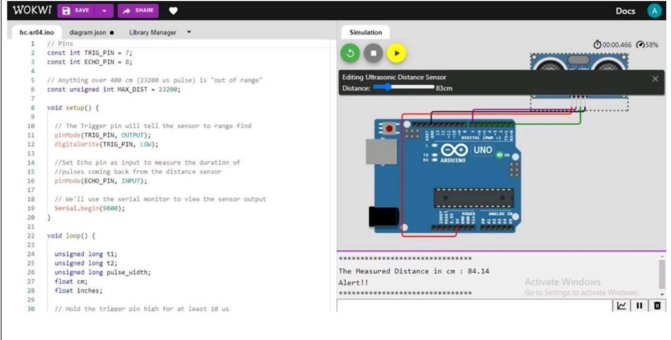

1. If the distance is more than 100 cms, it won’t alert

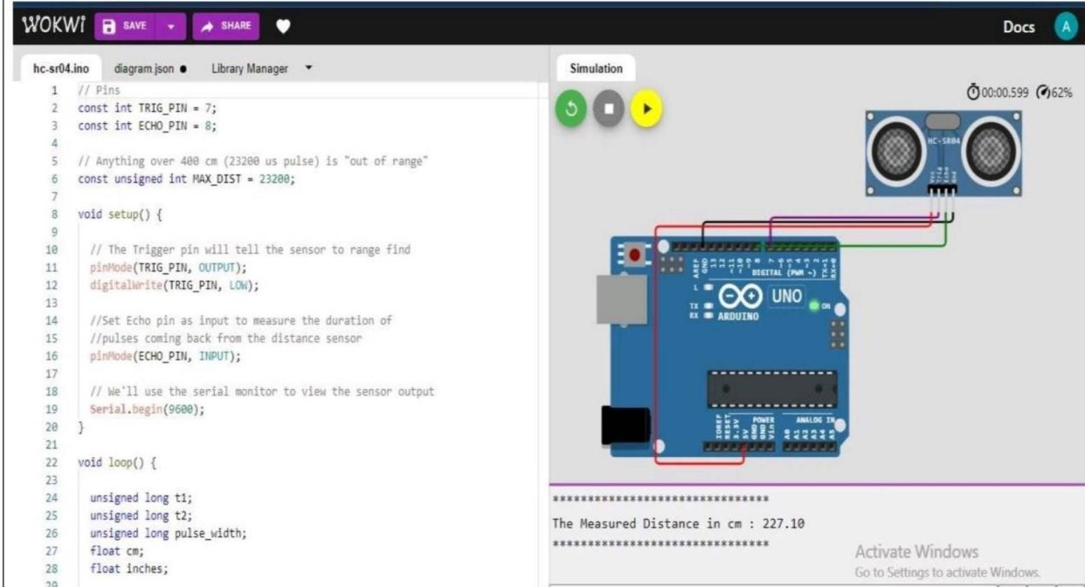

1. Simulation and code execution

